

|  |  |
| --- | --- |
|  | **COMSATS University Islamabad, Attock Campus**  **Lab Terminal Examinations (Spring 2024)** |

|  |  |  |  |  |  |  |  |  |  |
| --- | --- | --- | --- | --- | --- | --- | --- | --- | --- |
|  | | Department of: | | **Computer Science** | | | | |  |
|  | |  | |  | | | | |  |
| Class/Program: | | **BS(CS)-7th** | | Date: | **31/05/ 2024 (1:30 - 4:30)** | | | | |
| Subject: | **Compiler construction Lab EXAM** | | | Instructor: | | **Bilal Haider** | | | |
| Total Time Allowed: | | | **3-Hrs** | Maximum Marks: | | | | **50** | |
| Student Name: | | **Furqan Ahmed** | | Registration #: | | | **Sp20-Bcs-052** | | |
|  | |  | |  | | |  | | |

**Question 1**

Write an introduction of your compiler construction project.

**Answer:**

The key components of the project are as follows:

1. **Lexical Analysis (Scanning)**: The first phase involves breaking down the source code into tokens using a lexer or scanner. Tokens are the basic building blocks of the language, such as keywords, operators, identifiers, and literals.
2. **Syntax Analysis (Parsing)**: The parser takes the tokens generated by the lexer and organizes them into a syntax tree (also known as a parse tree). This tree represents the grammatical structure of the source code according to the rules of the MiniLang grammar.
3. **Semantic Analysis**: This phase ensures that the syntax tree follows the semantic rules of the language. It involves type checking, scope resolution, and ensuring that operations are semantically correct.
4. **Intermediate Code Generation**: The validated syntax tree is translated into an intermediate representation, which is a lower-level code that is easier to optimize and translate into machine code.
5. **Optimization**: The intermediate code is optimized for performance improvements. This includes eliminating redundant code, optimizing loops, and other code enhancement techniques.
6. **Code Generation**: The final phase involves translating the optimized intermediate code into target machine code or bytecode that can be executed by a virtual machine or hardware processor.
7. **Error Handling**: Throughout the compilation process, the compiler will detect and report errors in the source code, providing meaningful feedback to help developers correct their programs.

**Question 2**

Give a sample input and output for your compiler construction project?

**Answer:**

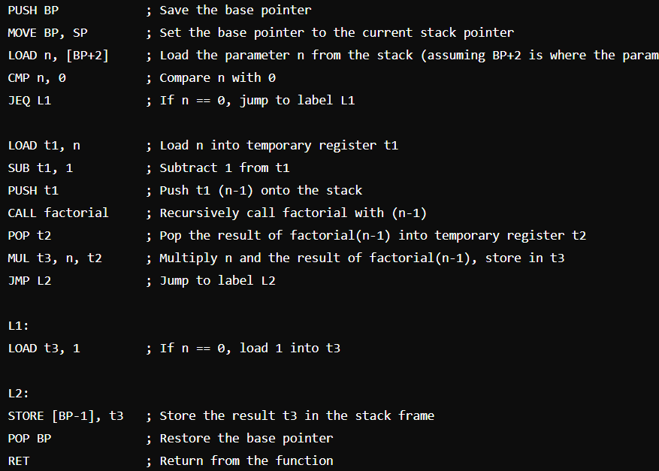

**Question 3**

**Create and implement RE and DFAs for the form below**

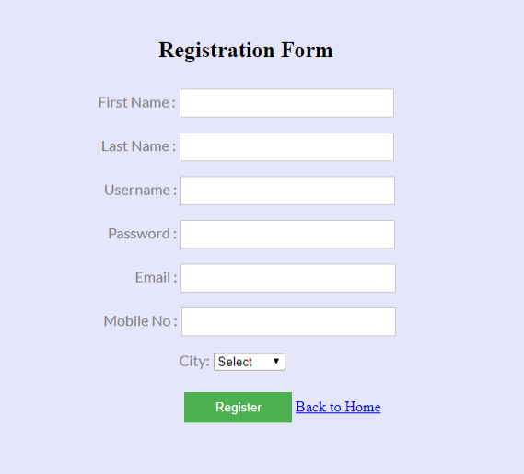

**You must use Regex to validate data.**

**Answer:**

**Code:**

# Define Regular Expressions

patterns = {

    "first_name": re.compile(r"^[A-Za-z]+$"),

    "last_name": re.compile(r"^[A-Za-z]+$"),

    "username": re.compile(r"^[A-Za-z0-9_]+$"),

    "password": re.compile(r"^(?=.*[A-Za-z])(?=.*\d)(?=.*[@$!%*?&])[A-Za-z\d@$!%*?&]{8,}$"),

    "email": re.compile(r"^[a-zA-Z0-9._%+-]+@[a-zA-Z0-9.-]+\.[a-zA-Z]{2,4}$"),

    "mobile_no": re.compile(r"^\d{10}$"),

}

# Sample Inputs

inputs = {

    "first_name": "John",

    "last_name": "Doe",

    "username": "john_doe",

    "password": "P@ssw0rd",

    "email": "john.doe@example.com",

    "mobile_no": "1234567890",

}

# Validate Inputs

for field, pattern in patterns.items():

    if pattern.match(inputs[field]):

        print(f"{field} is valid.")

    else:

        print(f"{field} is invalid.")

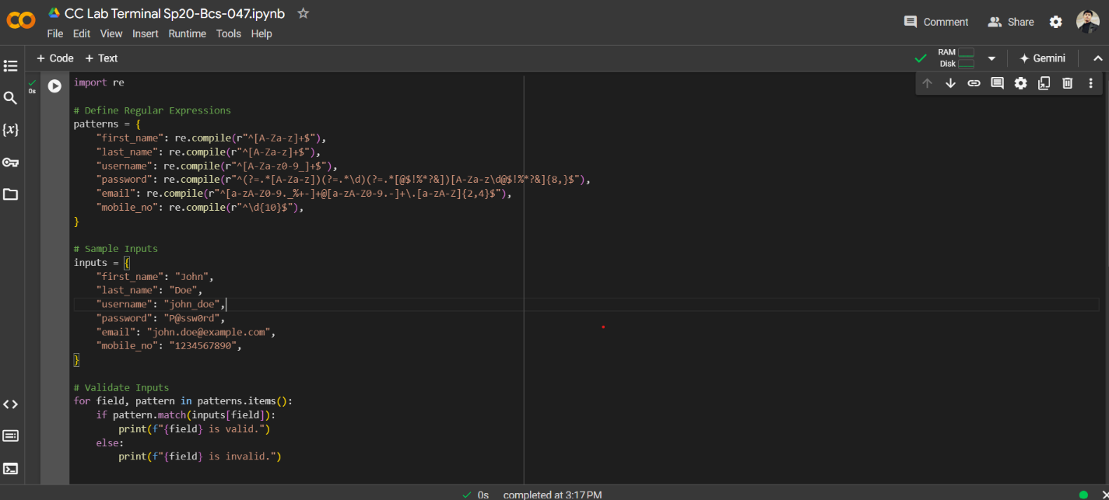

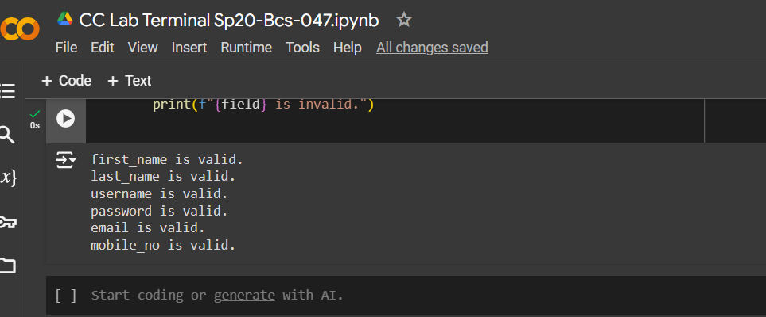

**Question 4:**

Write a program which generates symbol table for the code you submitted in question 3.

**Answer:**

import re

class SymbolTableEntry:

    def __init__(self, identifier, type_, scope, attributes=None):

        self.identifier = identifier

        self.type_ = type_

        self.scope = scope

        self.attributes = attributes if attributes else {}

    def __repr__(self):

        return f"{self.identifier}: {{'type': '{self.type_}', 'scope': '{self.scope}', 'attributes': {self.attributes}}}"

class SymbolTable:

    def __init__(self):

        self.table = []

    def add_entry(self, entry):

        self.table.append(entry)

    def __repr__(self):

        return "\n".join(str(entry) for entry in self.table)

# Define MiniLang code

mini_lang_code = """

function factorial(n) {

    if (n == 0) {

        return 1;

    } else {

        return n * factorial(n - 1);

    }

}

let result = factorial(5);

print(result);

"""

# Regular expressions to capture function definitions, variable declarations, and function calls

function_def_re = re.compile(r"function\s+(\w+)\s*\((.*?)\)\s*{")

variable_decl_re = re.compile(r"let\s+(\w+)\s*=\s*(.+?);")

function_call_re = re.compile(r"(\w+)\s*\((.*?)\);")

# Symbol table

symbol_table = SymbolTable()

# Parsing the MiniLang code

lines = mini_lang_code.split('\n')

scope = "global"

for line in lines:

    # Check for function definitions

    function_def_match = function_def_re.search(line)

    if function_def_match:

        function_name = function_def_match.group(1)

        parameters = function_def_match.group(2).split(',')

        parameters = [param.strip() for param in parameters if param.strip()]

        symbol_table.add_entry(SymbolTableEntry(function_name, "function", scope, {"parameters": parameters}))

        scope = function_name

        continue

    # Check for variable declarations

    variable_decl_match = variable_decl_re.search(line)

    if variable_decl_match:

        var_name = variable_decl_match.group(1)

        var_value = variable_decl_match.group(2)

        symbol_table.add_entry(SymbolTableEntry(var_name, "variable", scope, {"value": var_value}))

        continue

    # Check for function calls

    function_call_match = function_call_re.search(line)

    if function_call_match:

        func_name = function_call_match.group(1)

        arguments = function_call_match.group(2).split(',')

        arguments = [arg.strip() for arg in arguments if arg.strip()]

        symbol_table.add_entry(SymbolTableEntry(func_name, "function_call", scope, {"arguments": arguments}))

        continue

print("Symbol Table:")

print(symbol_table)

